**25. Hibernate Advanced Mappings - Eager vs Lazy Loading**

**Eager vs Lazy Loading**:

When working with an ORM, data fetching/loading can be classified into two types: eager and lazy.

1. Eager will retrieve everything
2. Lazy will retrieve on request

**Eager Loading**:

Eager Loading is a design pattern in which data initialization occurs on the spot.

* Eager loading will load all dependent entities
* Load instructor and all of their courses at once

If our database contains a lot of data then eager loading actually impact the performance of our application. It will slow down our application.

**Lazy Loading**:

Lazy Loading is a design pattern which is used to defer initialization of an object as long as it’s possible.

* Lazy loading will load the main entity first
* Load dependent entities on demand (lazy)
* In our app, if we are searching for a course by keyword
* Only want a list of matching courses

Eager loading would still load all students for each course that’s not good. We only want the titles or the descriptions of the courses but not all of the students.

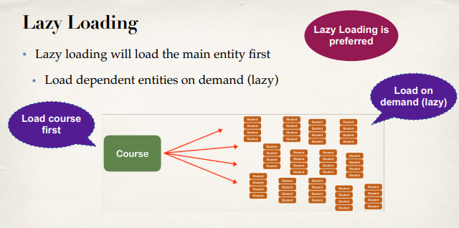

So the best practice is only load data when absolutely needed. Prefer Lazy loading instead of Eager loading.

**Real-World Use Case**:

1. Search for instructors

In our application we have a list of instructor. We also have a search option where we can search for

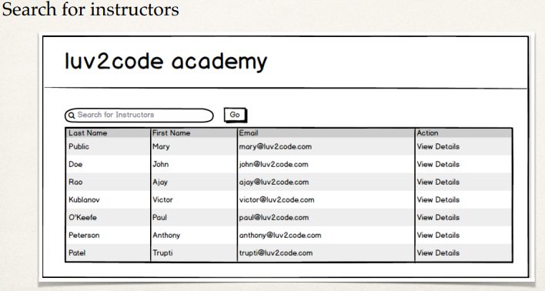

1. In Master view, use lazy loading
   1. In Master view, use lazy loading for search results
   2. Only load instructors … not their courses
2. In Detail view, retrieve the entity and necessary dependent entities
   1. In Detail view, retrieve the entity and necessary dependent entities
   2. Load instructor AND their courses

25. Hibernate Advanced Mappings - Eager vs Lazy Loading